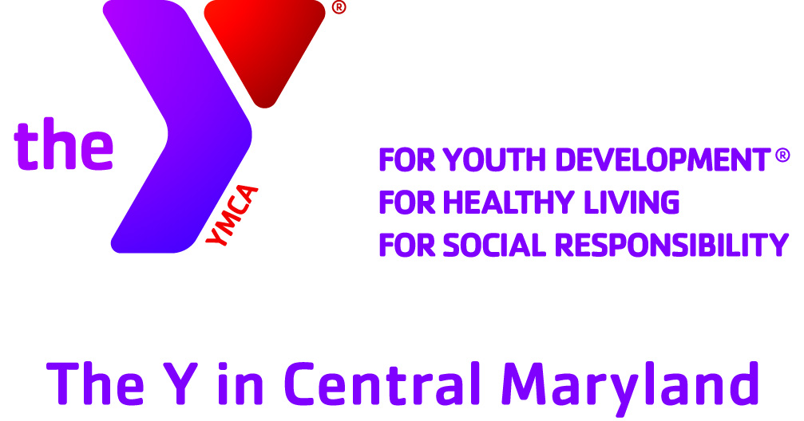

**FALL PICKLEBALL TOURNAMENT**

**At the Y in Ellicott City**

**Saturday October 14, 2017**

**Info:**

* $30 per team – payment due at time of entry
* Men’s Doubles – 18 Team Maximum
* Women’s Doubles – 18 Team Maximum
* 3 pools of 6 teams may guarantee 5 – 15 pt games
* Semi-Finals/Finals (best 2 of 3) 10 point games

Gender ___ male ___ female

Participant 1:

Name__________________________________

Email __________________________________

Mobile phone ___________________________

Circle ranking 2.5 3.0 3.5 4.0

Participant 2:

Name__________________________________

Email __________________________________

Mobile phone ___________________________

Circle ranking 2.5 3.0 3.5 4.0

Email to: Charles Brown Chbrown1945@gmail.com

**Entries & Payments due by**

**October 9, 2017**

Mail to: The Y in Ellicott City (Dancel)

[4331 Montgomery Rd., Ellicott City, MD 21043](https://www.google.com/maps/dir/''/dancel+ymca+in+ellicott+city+md/@39.2519912,-76.8838694,12z/data=!3m1!4b1!4m8!4m7!1m0!1m5!1m1!1s0x89c81f929e9c745d:0x4f8ce02b40fef6ec!2m2!1d-76.8138294!2d39.2520122)

Bring to: The Y in Ellicott City (Dancel)

-+

Make checks out to: The Y in Central Maryland